Computer Science Curriculum Overview
Key Stage 3
Please see below details of the KS3 curriculum we offer at St Joseph's College. In Key Stage 3 assessment will be through a variety of practical project, multiple choice quizzes and exam style short/long answer questions. Students will have a portfolio that they keep in school which will document their progress and keep printed copies of key pieces of work.
Year 7
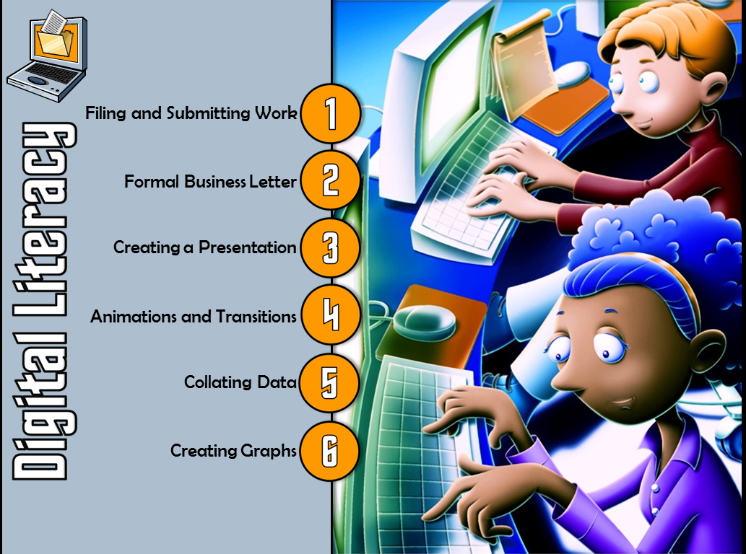 | 7.1 Digital Literacy  Gives learners a basic introduction to key Information Technology skills through using Microsoft Office tools. This includes attaching files and using OneNote, writing a formal business letter in Word, use of interactivity in PowerPoint and basic formulas and graphs in Excel.
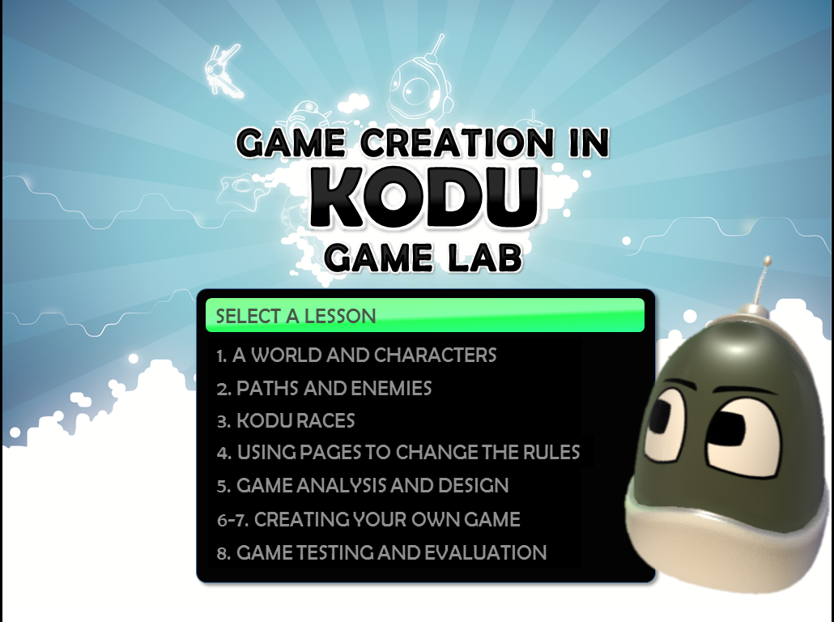 | 7.2 Game Creation in Kodu Game Lab  Teaches learners the fundamentals of games programming using Kodu Game Lab, which is a visual game development environment. Using this learners will develop a range of key skills which include drawing and sculpting a world, adding character and objects. The use of When and Do instructions to control characters and objects including the use of paths and pages. Once learners have built their skills they are required to design, create, test and evaluate their own game; following the Systems Lifecycle.
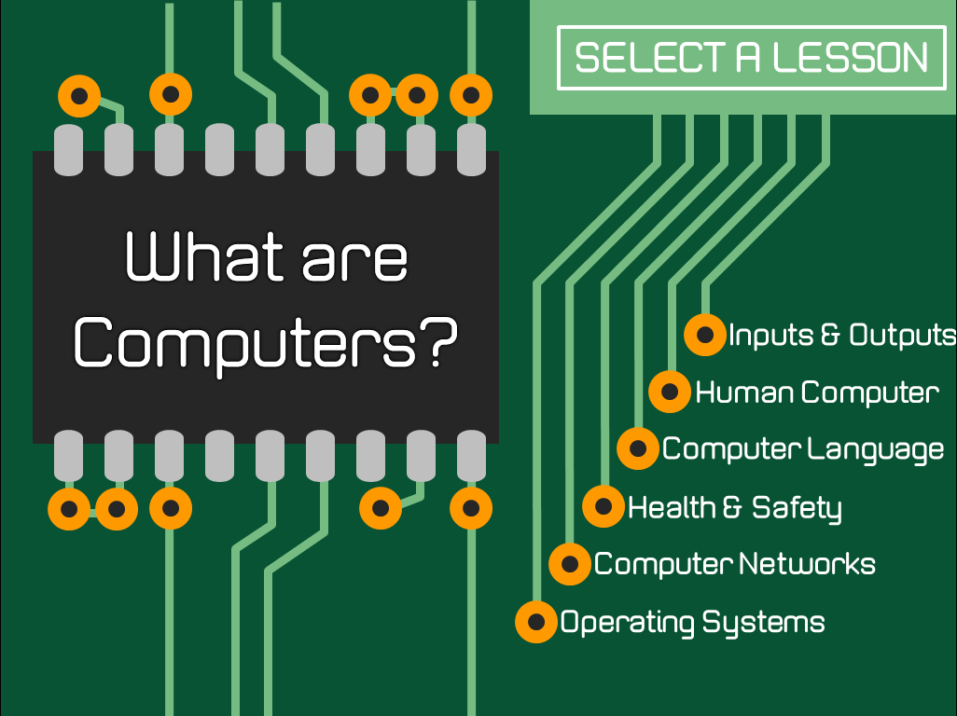 | 7.3 What are Computers? Part I  Gives learners an understanding of the key components that make up a computer system, including inputs and outputs and hardware. In addition they will be introduced to binary and how to convert between binary and denary numbers and will gain a basic understanding of computer networks and operating systems. They will also look at health and safety issues surrounding the use of computers.
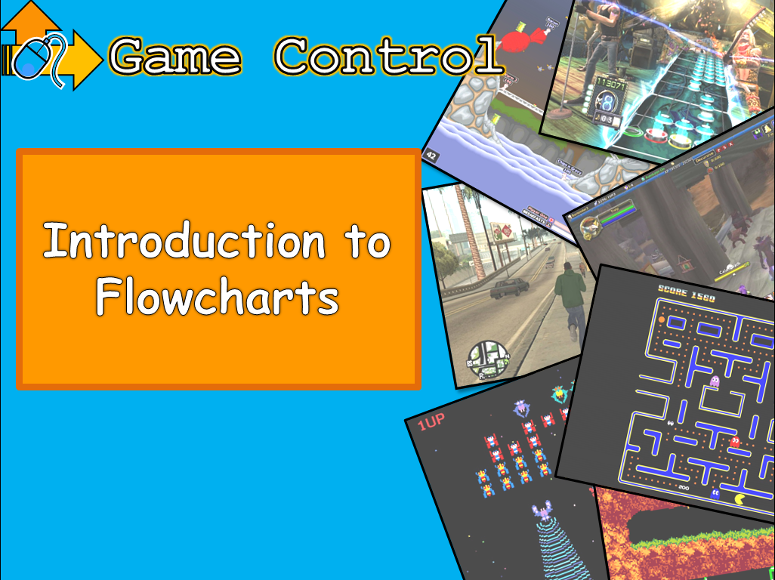 | 7.4 Algorithms and Programming  This will give learners an introduction to algorithms in the form of flow charts and pseudo code and introduce them to key programming concepts in Scratch. They will then go on to use these skills in the development of a virtual pet application.

Year 8
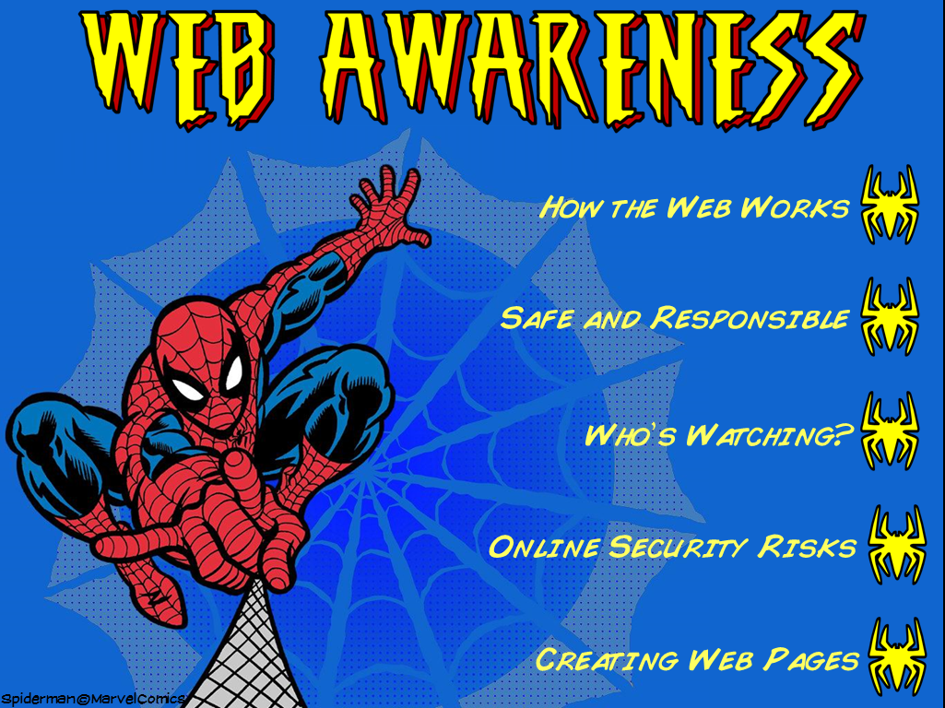 | 8.1 Web Awareness  Gives learners an understanding of the fundamentals of the World Wide Web. Covering how the Web works, how to be safe and responsible online, an understanding of ethical issues surrounding the use of the Web and also look at security risks and how they can be prevented. This finishes with students siting an in house exam to examine their understanding of e-safety
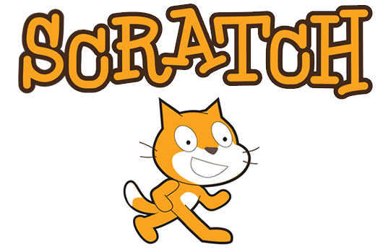 | 8.2 Scratch Independent Project  Learners will further develop their programming skills and their ability to problem solve using programming by undertaking an independent project using Scratch. This year the students will be creating their own version of the popular mobile game Flappy Bird.
8.3 What are Computers? Part II
This will be a continuation of ‘What are Computers?’ in year 7. This will build upon the knowledge developed in year 7 and introduce some of the more complex concepts of modern computing.
8.4 VB.NET programming pt1
This gives learners a basic understanding of programming terminology with a practical element in VB.NET. Through a series of six lessons learners will be introduced to the basic programming terminology for instance data types, selection and iteration. Learners will be given the building blocks to extend their programming skills by adding to existing programs or extending their knowledge through Codecademy.
Year 9
9.1 Computer Science Theory
This scheme of work is designed to give learners an introduction to the main concepts in the GCSE Computer Science course. Students will examine topics such as binary addition, subtraction, Two’s Compliment and many more. Assessment will be through multiple choice quizzes and some sample GCSE questions from past papers.
9.4 VB.NET programming pt2
Learners will further their experience and skills in VB.NET in preparation for its use on the AQA GCSE Computer Science course. As well as revisiting some of the previous unit’s content there will be an element of independent study built into this unit for learners to start thinking about developing programs for themselves.

Key Stage 4
In Key Stage 4 we offer a GCSE in Computer Science examined by AQA. The course examines key Computer Science theory topics such as Data Representation, Networking and Technology in the wider society but also focuses heavily on programming. The programming language we use for the duration of the course is VB.NET developed using the Visual Studio developer environment. The course is examined through two theory papers worth 40% each (subject content is divided equally between the 2 papers). The remaining 20% is examined through a Non Exam Assessment, which is completed over 20 hours.

Key Stage 5
In Key Stage 5 we offer AQA A-Level Computer Science. The course is a continuation of what is assessed at Key Stage 4 examining the same content but in much greater depth. The course retains a heavy programming focus with one of the two exams being a practical programming exam taken in a computer room. There is also a Non Exam Assessment worth 20% of the A-Level which allows the students to undertake a project of their choosing, creating a practical program along with written work that documents the development process.

